How to Create and Setup a Windows VM in Proxmox

Hi, I’m Raf and today we are going to Setup a Windows VM in Proxmox.

For creating the VM you do need to Have a Server setup and running Proxmox. If you don’t have Proxmox setup yet, then LearnLinuxTV has a great tutorial on it:

<https://youtube.com/playlist?list=PLT98CRl2KxKHnlbYhtABg6cF50bYa8Ulo>

Overview:

1. Create a VM
   1. Create VM
   2. Set VM Settings
   3. Add Drivers
2. Install Windows
   1. Click Install Now
   2. Select Version
   3. Load Drivers
   4. Change Default Password
3. Configure Windows
   1. Install Drivers
   2. Pirate Windows
   3. Update Windows
   4. Setup RDP
   5. Setup Multiple User RDP
   6. Make Multiple User RDP Free
4. Other
   1. Disable Ctrl+Alt+Del at Login
   2. Install Audio Driver
   3. GUI Performance Settings

Download Links:

Windows Server 2022: [Windows Server 2022 | Microsoft Evaluation Center](https://www.microsoft.com/en-us/evalcenter/download-windows-server-2022) ( Select “ISO downloads” )

Virtio-Win: [virtio-win-pkg-scripts/README.md at master · virtio-win/virtio-win-pkg-scripts · GitHub](https://github.com/virtio-win/virtio-win-pkg-scripts/blob/master/README.md) ( Select “Stable virtio-win ISO” )

Creating a Windows VM

So first, we have to create a VM on Proxmox for Windows to run on, so here are the steps:

0. Create VM

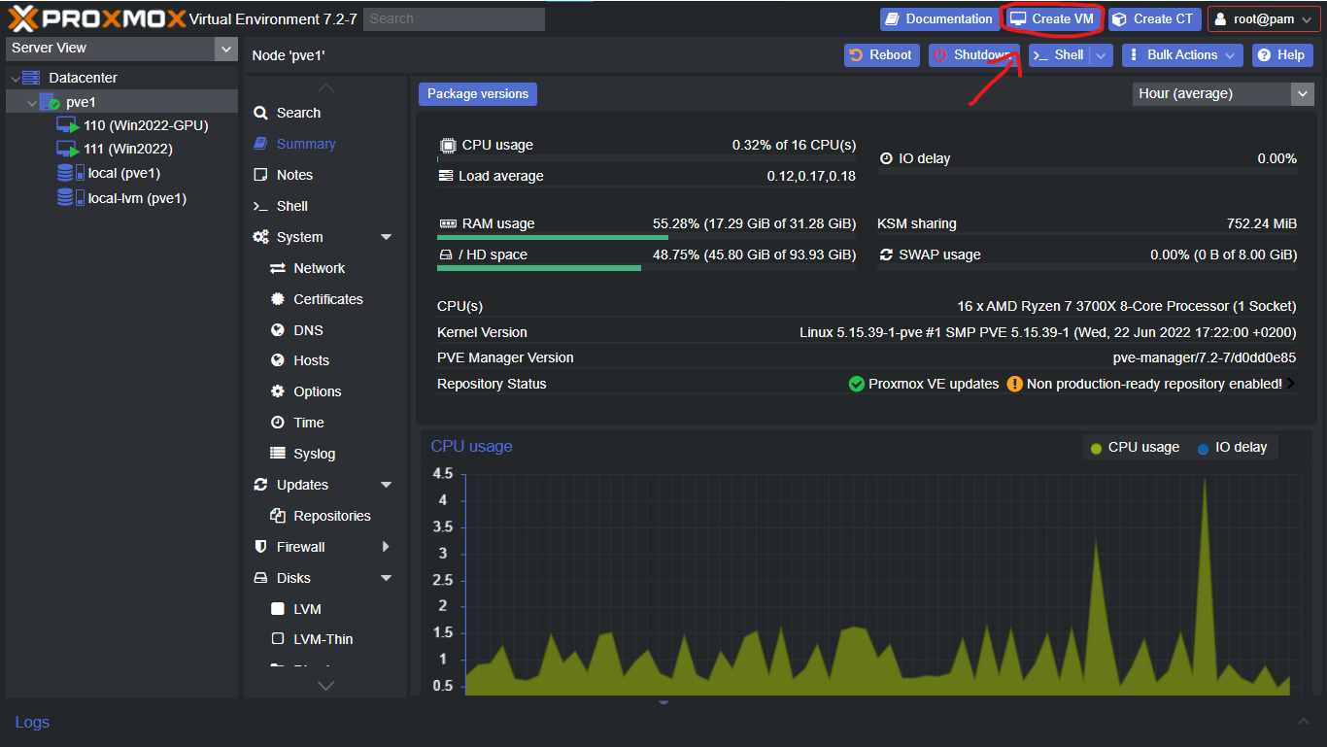

The First Step is to create a VM. To do that click the “Create VM” Button on Proxmox’s Dashboard.

Now we have to set the Specifications for the VM.

1. General ( Win2022 )

You can keep this to whatever you want, Since I’m setting up Windows Server 2022 ( For the Tutorial ) I’m calling the VM Name Win2022-Test. And I’m also enabling “Start at boot”, so that whenever we start the server the VM starts Automatically.

2. OS ( Windows Server 2022 )

Over Here you are going to select the Windows ISO you Downloaded, in my case it’s Windows Server 2022. And for GuestOS the type is “Microsoft Windows” and Version “11/2022”.

3. System ( q35, OVMF, VirtIO SCSI Single, TPM 2.0 )

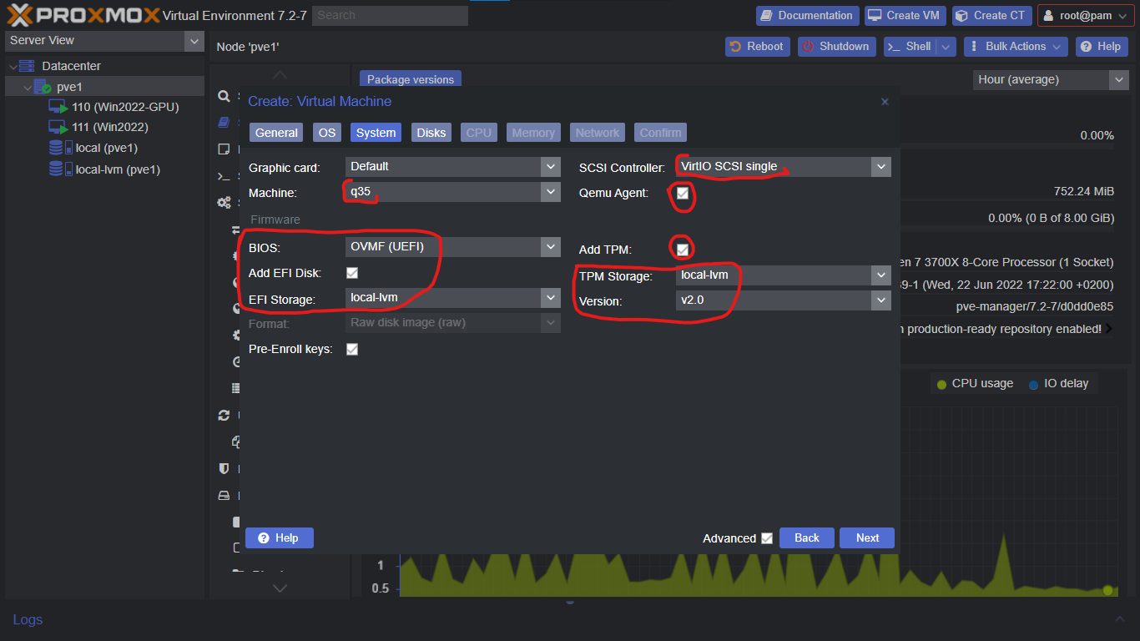

In the System Tab, the machine is going to be “q35”. BIOS is “OVMF (UEFI)”, Enable “Add EFI Disk” and for EFI Storage select “local-lvm”. SCSI Controller is “VirtIO SCSI Single” and Enable QEMU Agent. Also Enable TPM, store it in “local-lvm” and select v2.0.

4. Disks ( SCSI 32GB )

For Bus/Device select “SCSI”, Storage is “local-lvm” and size is 32GB ( you can increase the storage size later ). If you’re using an SSD then Enable “SSD Emulation”. For Performance Enable “IO Thread” and “Discard” Options.

5. CPU ( 2 )

For Now we are going to give it 2 Cores ( you’re giving threads here though ), and for “Type” select host.

Note: You can’t transfer a VM from one node to another when you select the “Type” as host.

6. Memory ( 4GB )

Set the Memory to 4096 on both of them. This gives the VM 4GB.

7. Network ( VirtIO )

For Network, Select the model to VirtIO (paravirtualized).

8. Confirm

Click Finish.

9. Add Drivers ( VirtIO Win )

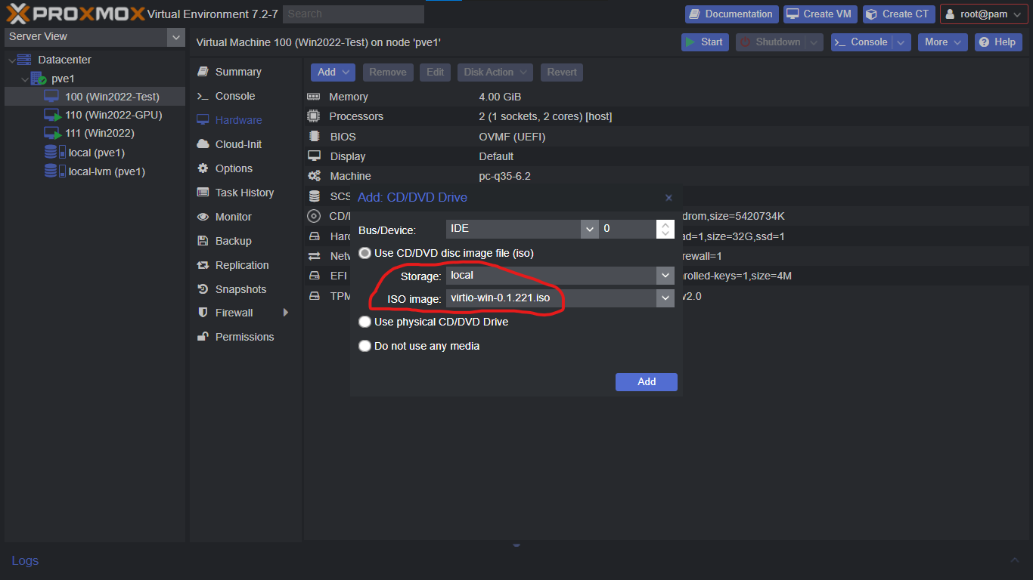

Now Select the VM, go to the “Hardware” Tab and Add a CD/DVD Drive. For Storage select “local” and for ISO Image select virtio-win.iso.

Install Windows

Alright, Now we’re Ready to Start the VM and get Windows Installed!

0. Start the VM.

Select the VM and go to the “Console” Tab, now click “Start Now” to start the VM. And while it’s starting up, keep pressing a key until windows boots up.

Note: If you want the View to be Fullscreen, then go to the Control Bar and click the Fullscreen Icon.

1. Install Windows

Click “Next”, the click “Install Now”.

2. Select the Operating System Version

Select “Datacenter (Desktop Experience)” and click Next. Now Agree to the License Terms, and click Next.

3. Select Custom Install

Now the Type of Installation is going to be “Custom”

4. Select Hard Drive ( Select the VirtIO Win drive and select the 2k22 file )

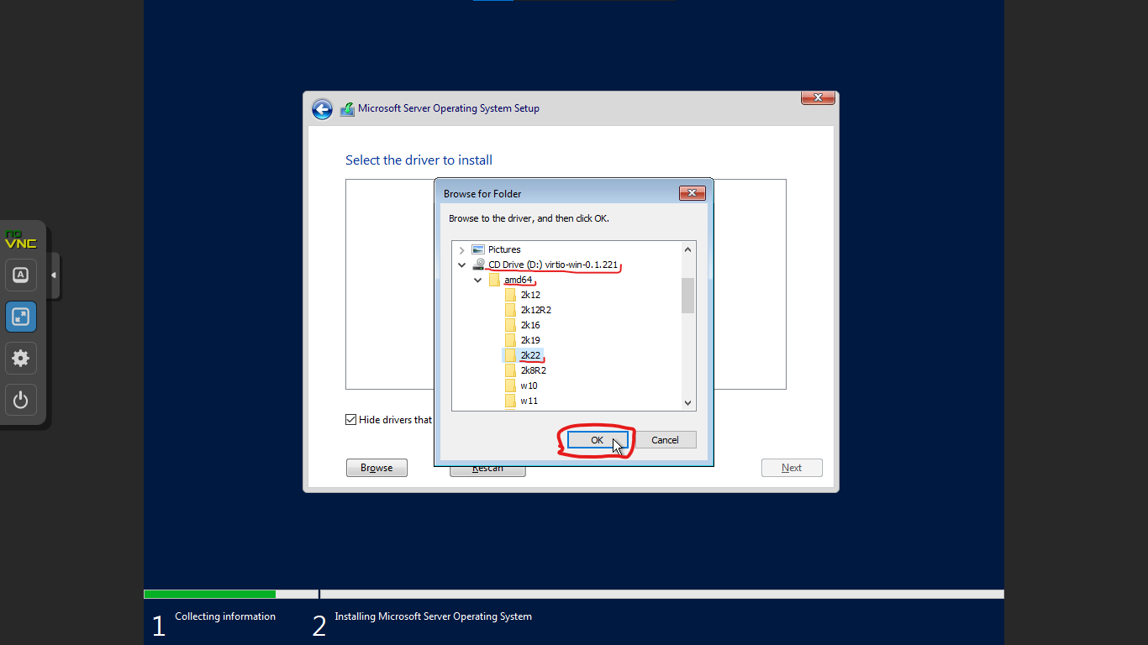

Now currently, it doesn’t show any hard drives and so to fix that we have to load the drivers.

To Load the driver for it, Click “Load Driver”, and now click the “Browse” Button. Select the File “VirtIO-Win/amd64/2k22”, and click OK. Click “Next” and Now we should see our Drive!

Select the Drive and Click “Next” so that Windows Starts Installing.

5. Set Password

Set the Password for the Administrator Account.

6. Log in to Windows

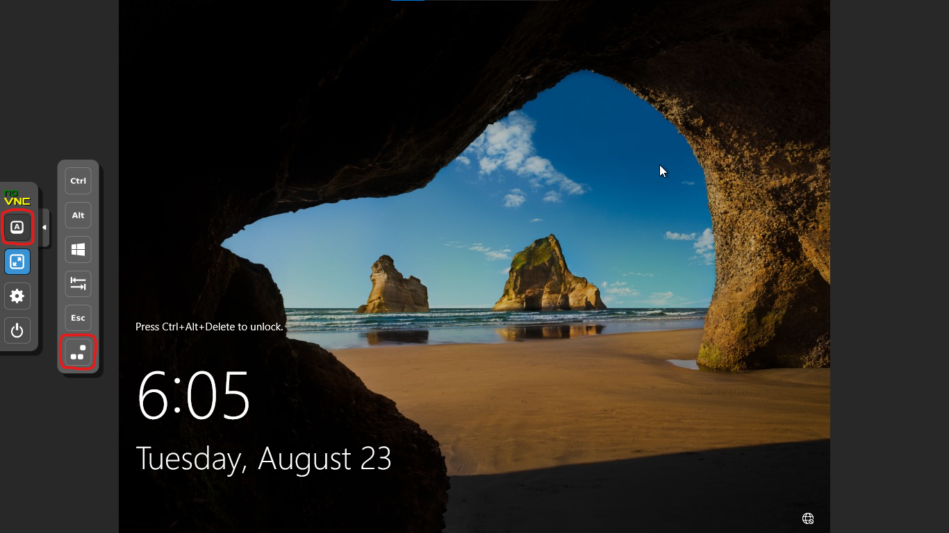

To Login, you first have to press Ctrl+Alt+Del. So to do that Open the “Control Bar”, Click the “Show Extra Keys” Button, and Select “Send Ctrl-Alt-Del”. Now Just put in the Password you set Earlier and you’re logged in!

Configure Windows

So Windows is now Installed, But we do still have to set some things up.

0. Install Drivers

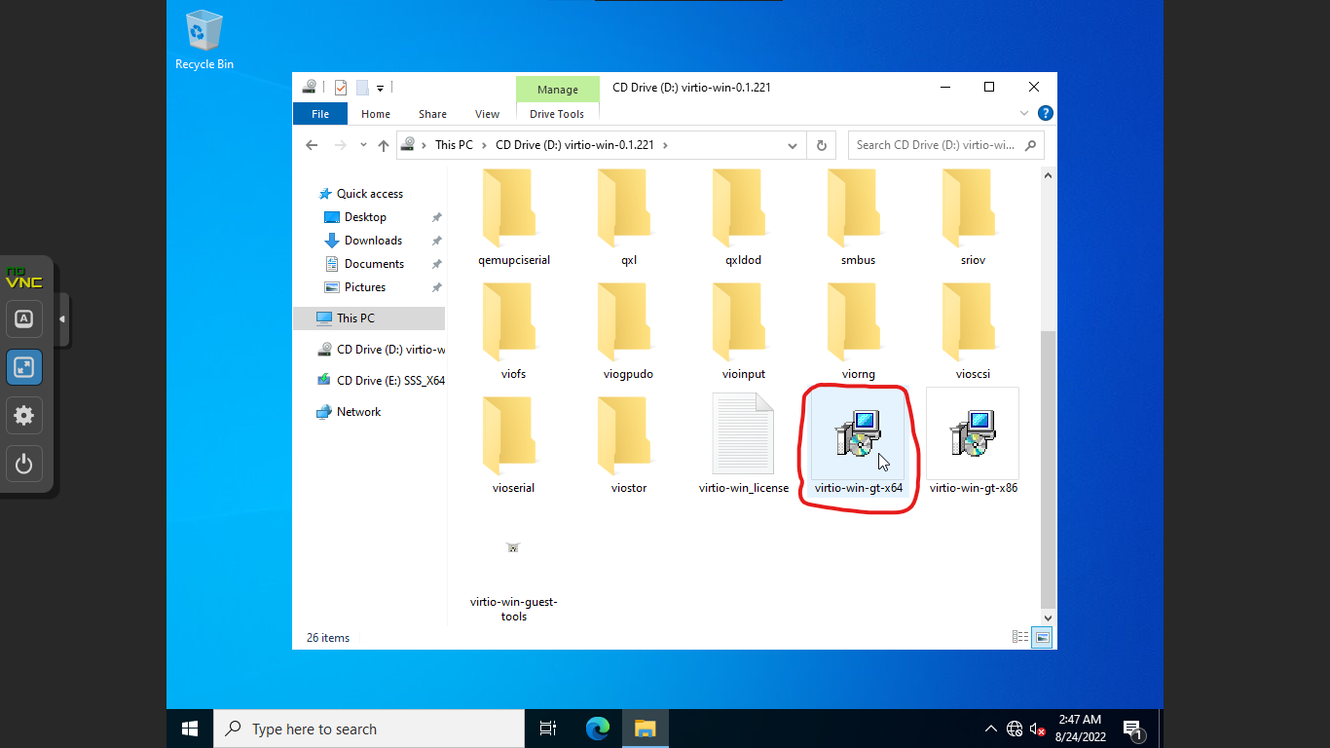

0a. Open File Explorer

0b. Select the virtio-win CD Drive

0c. Run and Install the virtio-win-gt-x64.msi file

1. Pirate Windows

1a. Open Edge

1a. Download & Install 7Zip: [Download (7-zip.org)](https://www.7-zip.org/download.html)

1b. Download MAS: [Releases · massgravel/Microsoft-Activation-Scripts · GitHub](https://github.com/massgravel/Microsoft-Activation-Scripts/releases)

Now to Activate Windows we are going to Download this tool called “Microsoft Activation Scripts” or MAS for short.

1c. Run MAS

Extract the .7z File with 7zip, Go in the “All in One” Folder and Run the “MAS_AIO.cmd” file.

1d. Change Win Edition from DatacenterEval to Datacenter

Go to “Extras” and select “Change Windows Edition”; Now select “ServerDatacenter”. After that Restart the System.

1e. Activate Windows!

Now, Open MAS (again) and this time select “KMS38” and then “KMS38 Activation”. Once it’s done then Windows should be Activated!

3. Update Windows

3a. Open Settings

3b. Go to Update & Security

3c. Click Check for Updates

3d. Click Install Now

3e. Restart the System

3. Setup RDP

3a. Open Server Manager

Open “Server Manager” and Select “Local Server” from the Sidebar.

3b. Find IP Address

Go to your Router IP, Sign in and Find the Current IP of your PC.

3c. Set IPv4 to Static

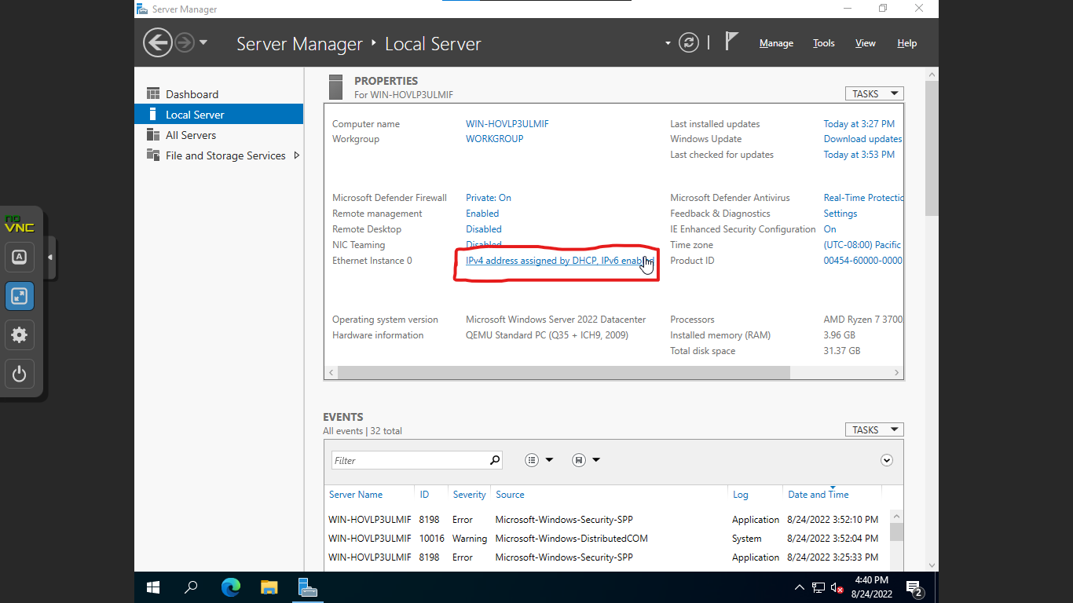

Click on IPv4 Address, Right Click “Ethernet Instance 0”, Select “Properties”, Select “TCP/IPv4” and Click “Properties”. Now Select “Use the following IP address” and Input the Details.

IP Address = The Current IP | Subnet Mask = 255.255.255.0 | Default Gateway = Router IP DNS 1 = 1.1.1.1 | DNS 2 = 1.0.0.1

3d. Enable RDP

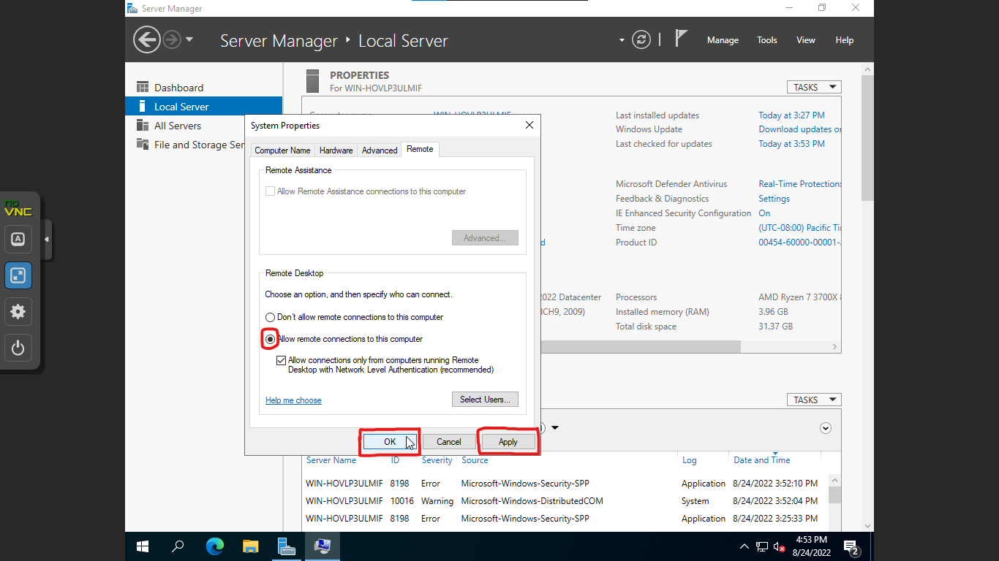

Click on Remote Desktop and Click on Allow remote connections to this computer. Now you can connect to this computer using any RDP Client ( like Window’s default RDP Client )

Now this next step is completely optional, but what it allows you to do is for 2 or more people to simultaneously connect to the same windows machine with different user accounts ( which is pretty cool ).

4. Enable Multiple User RDP

4a. Open Server Manager

4b. Enable Remote Desktop Services in Server Roles

Click “Manage” in the Top Left, and Select “Add Roles and Features”. Now Click “Next” until you reach “Server Roles” and in there, select “Remote Desktop Services”.

4c. Select Appropriate Roles in Role Services

Select “Role Services” and in there, Select “Remote Desktop Connection Broker”, “Remote Desktop Licensing” and “Remote Desktop Session Host”.

4d. Start Install

Select “Confirmation”, Check the “Restart Server Automatically” Checkbox and click “Install”.

4e. Launch Computer Management

Click “Tools” in the Top Left and select “Computer Management”.

4f. Add Users

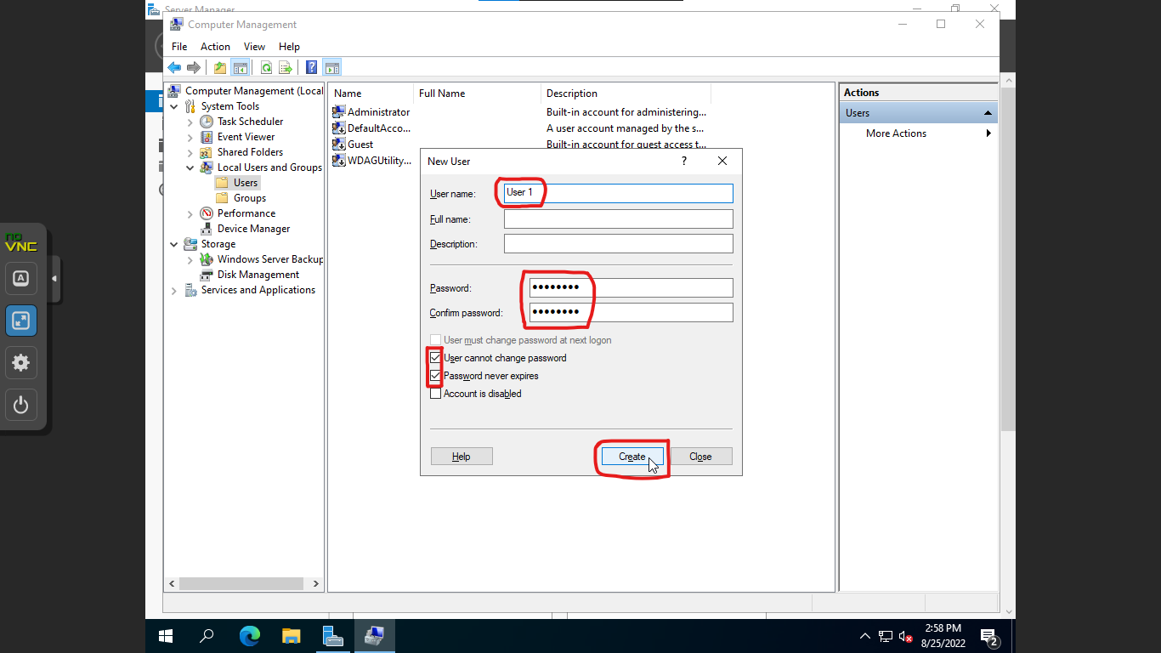

Select “Local Users and Groups” and in there Select “Users”. Right Click the Empty Space and Select “New User”, Input the Details and Uncheck “User must change password at next login”, Also Check the “User cannot change password” and “Password never expires” Checkboxes. Now Click “Create”.

Note: You can create as many Users as you want, I’m Creating 2 Users.

4g. Give User Administrator Privileges

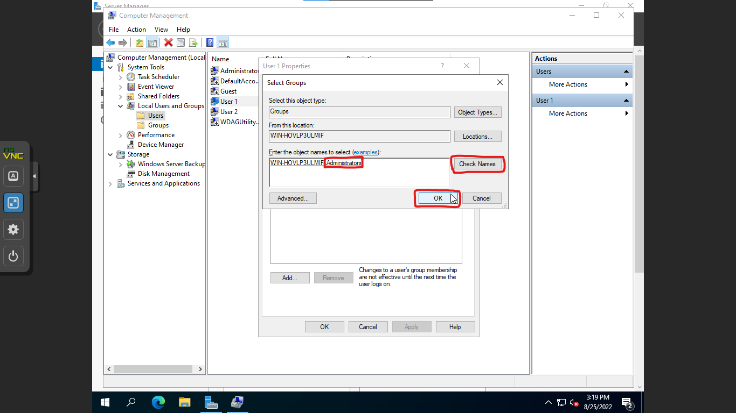

Right Click the User and Select “Properties”, Now select “Member of” and click “Add”. Input ‘Administrators’ in the Text Field and Click “Check Names”, Click “OK”, Click “Apply” and “OK”.

Note: You have to do this for Every User you created.

4h. Activate RDP Licence Manager ( Optional )

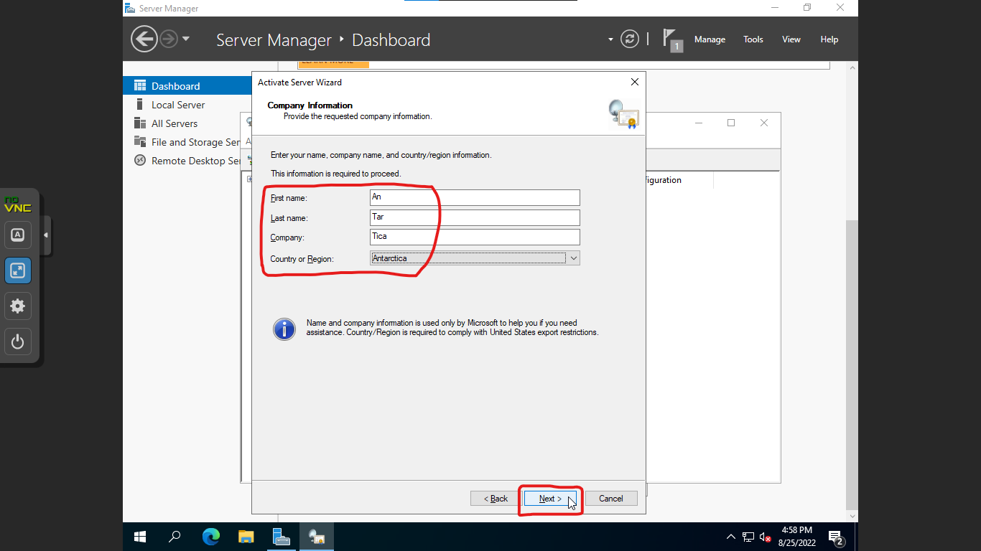

Click “Tools” in the Top Left and in “Remote Desktop Services” Click on “Remote Desktop Licensing Manager”. Right Click your PC and select “Activate Server”. Now Click “Next” Until you Reach the ‘Company Information’ Section. Over here Input the Details and Click “Next” Twice.

Now if you have a Licence Key then Click “Next” and Activate it, If you don’t have one then Uncheck the Checkbox and Click “Finish”.

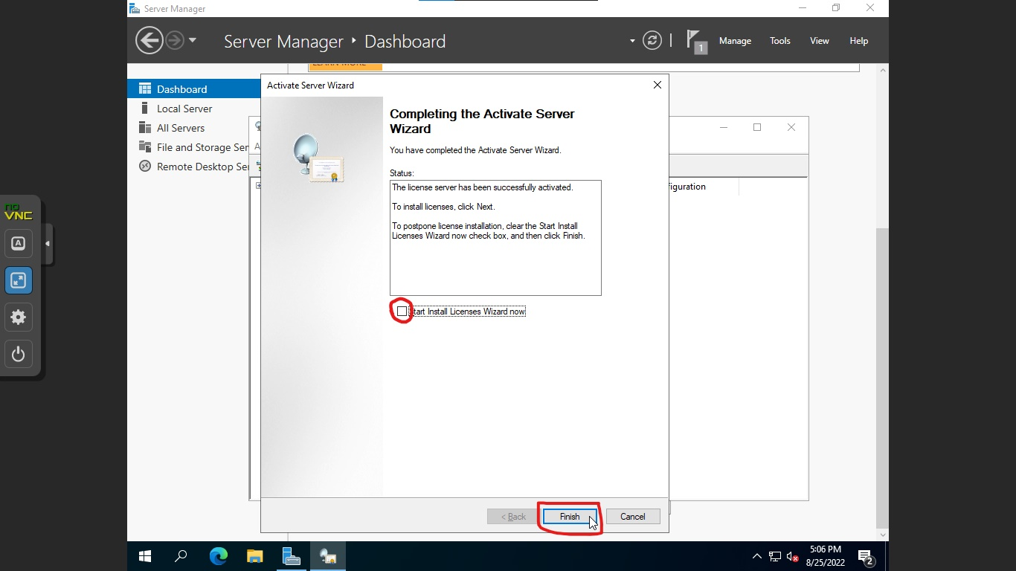

5. Make Multiple User RDP Free

5a. Go to Time & Language in Settings

5b. Move Year to 2036

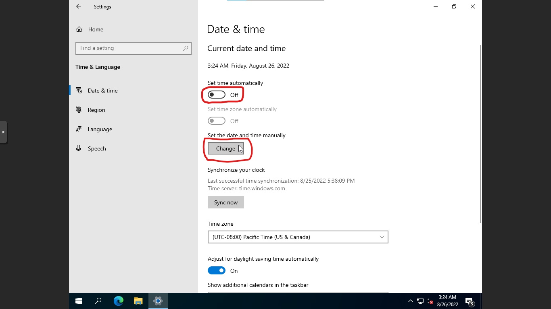

Turn off the “Set Time Automatically” Option and Change the Year to 2036.

5c. Run gpupdate

Right Click the Windows Logo and Select “Run”, and Input “gpupdate” and press Enter.

5d. Open Registry Editor

Right Click the Windows Logo and Select “Run”, in the text field Input “regedit” and press Enter.

5e. Find Grace Period Folder

Go to: “Computer\HKEY_LOCAL_MACHINE\SYSTEM\CurrentControlSet\Control\Terminal Server\RCM”

5f. Delete Grace Period Folder

Now to Delete the Folder, we first have to give ourselves the permissions to delete it.

So for that Right Click the “Grace Period” Folder and Select “Permissions”. Now we are going to add the Administrator user in here.

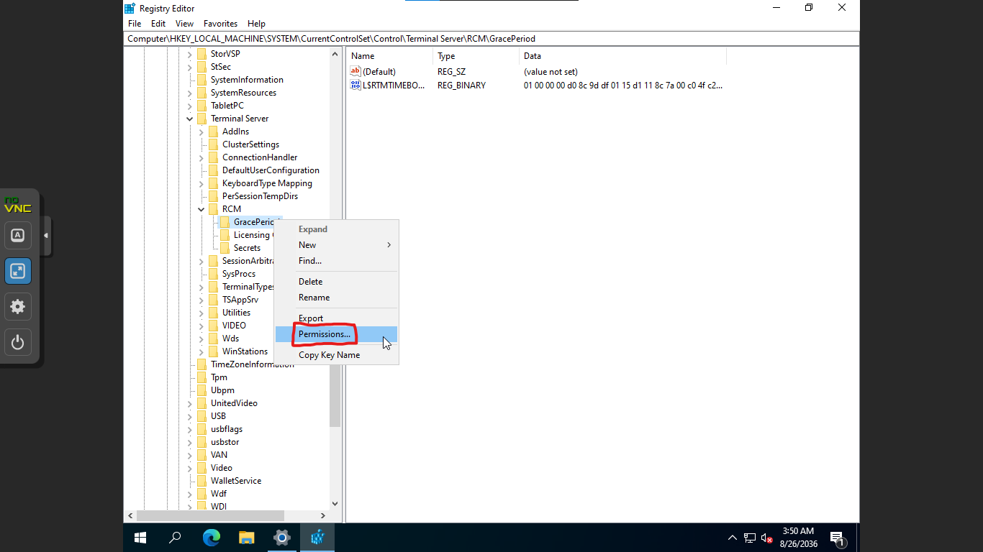

Click on “Add” and in the text field Input “Administrator”, Click “Check Names” and now click “OK”. Now Select the “Administrator” User and allow Full Control on that user.

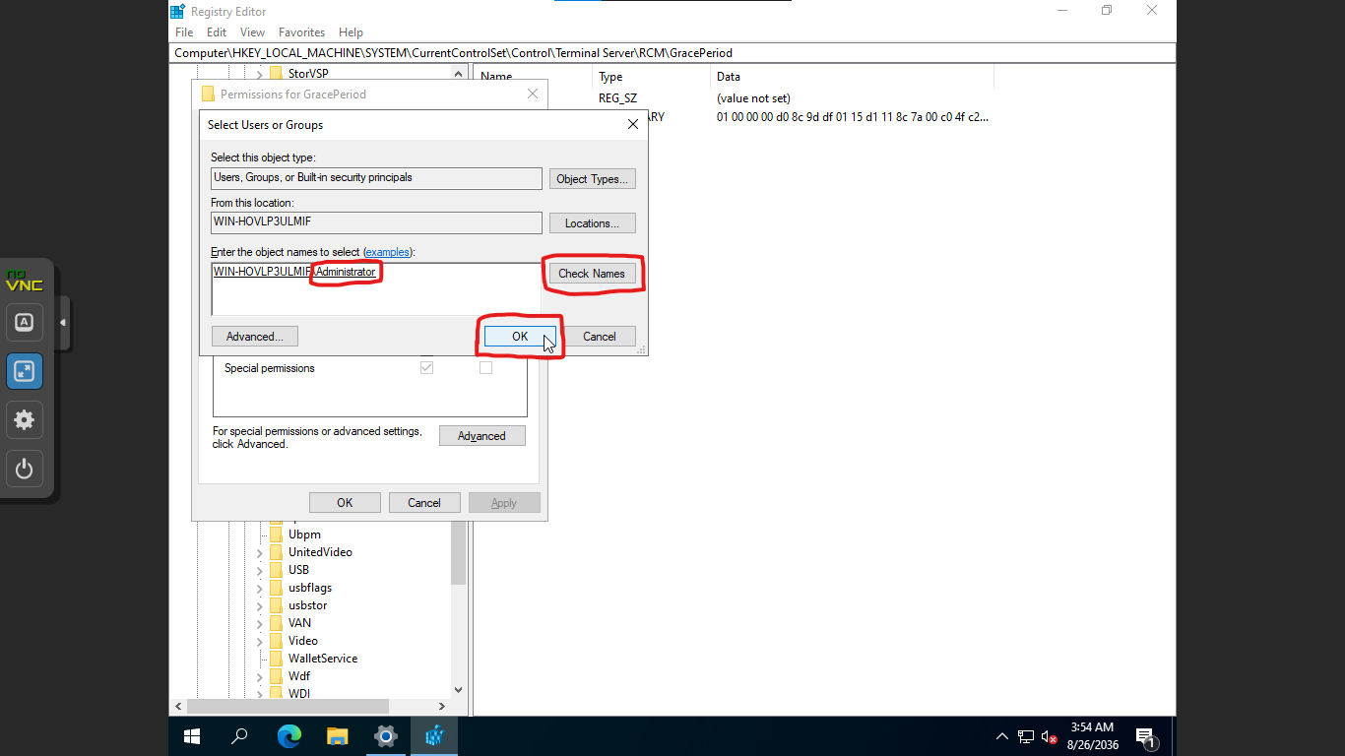

Click “Advanced” and make sure that the Owner is ‘Administrators’. Now Click “OK” then “Apply” and “OK”. And Finally now you can delete the Folder!

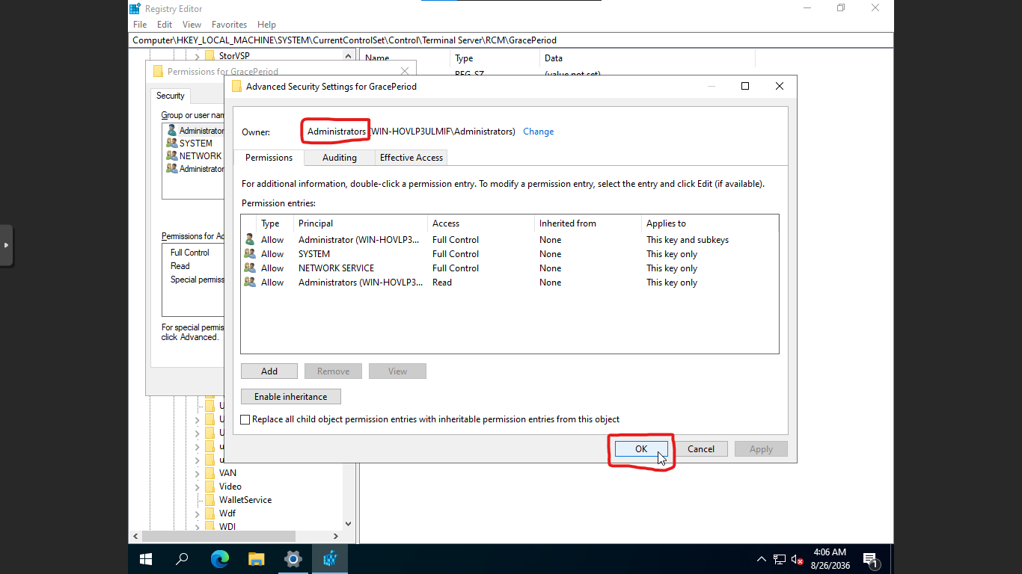

5g. Reboot the System

5h. Set Year back to Normal

Turn on the “Set Time Automatically” Option and wait for it to complete. And Now you can use Multiple User RDP until 2036!

Other Things

1. Disable Ctrl+Alt+Del at Login:

1a. Run secpol.msc

Right Click the Windows Logo and Select “Run”, and Input “secpol.msc” and press Enter.

1b. Go to: Local Policies\Security Options

1c. Enable "Interactive logon: Do not require CTRL+ALT+DEL"

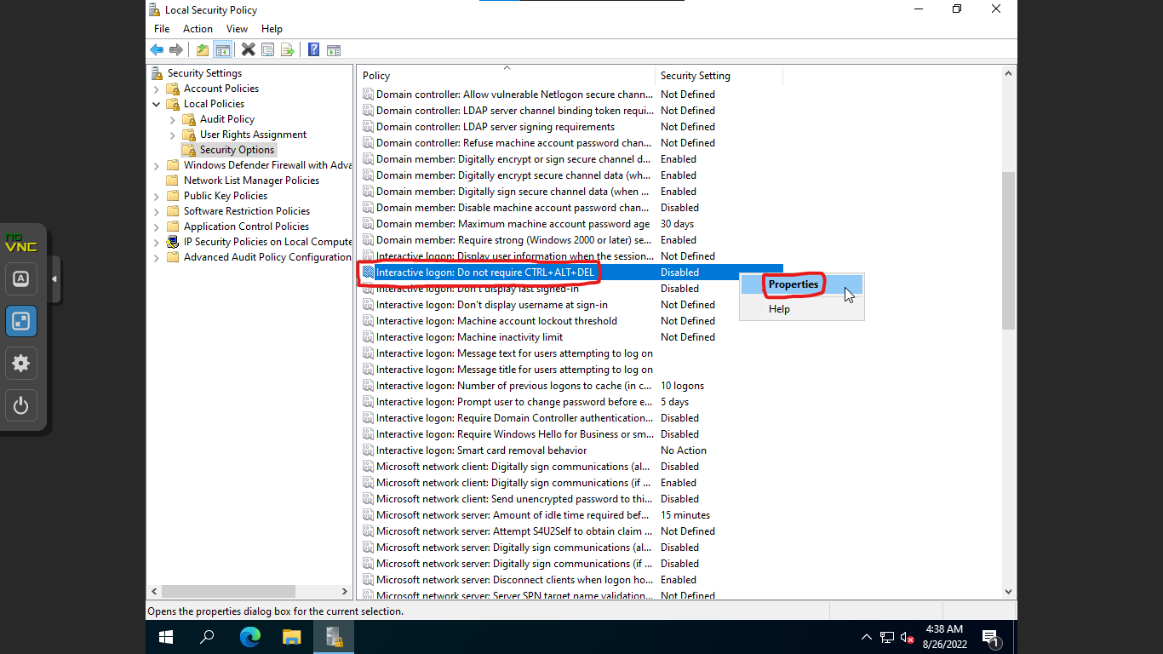

Right Click the Option and Select “Properties”, Now Select “Enabled” and click “Apply” then “OK”.

2. Audio Driver

2a. Download Audio Driver

Go to: [VB-Audio Virtual Apps](https://vb-audio.com/Cable/) and Download the Driver.

2b. Install it.

Unzip the Downloaded File and Run “VBCABLE_Setup_x64.exe”

2c. Reboot the System

3. GUI Performance Settings

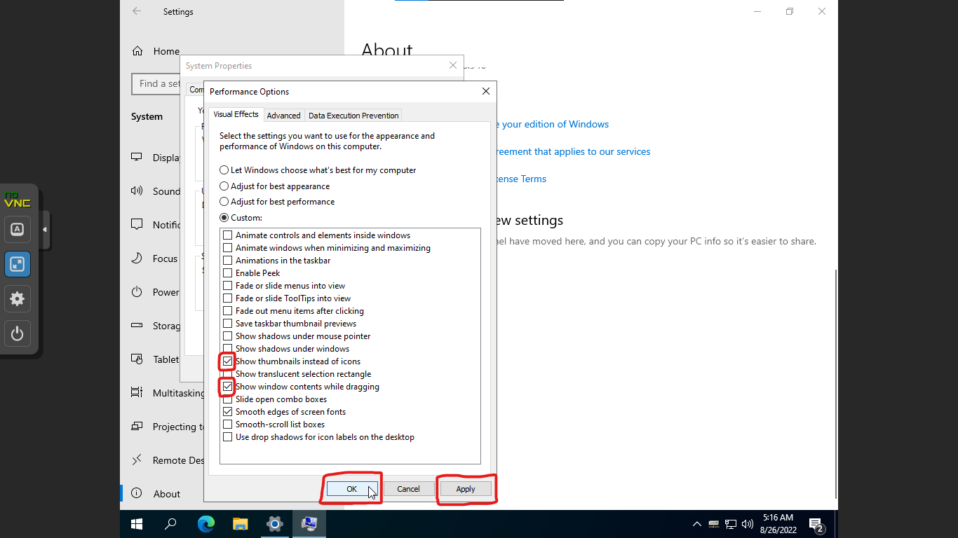

3a. Go to: Settings > System > About > Advanced System Settings

3b. In Advanced > Performance, Click Settings

3c. Select "Show thumbnails instead of icons" and "Show window contents while dragging"

The End!